Create a Spring Web Project using Maven
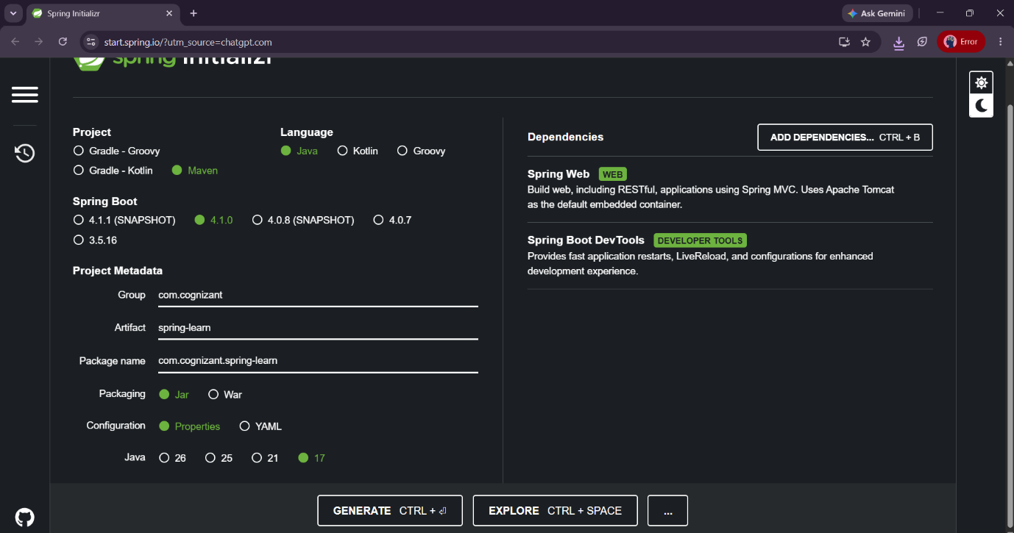

package com.cognizant.springlearn;

import org.springframework.boot.SpringApplication;
import org.springframework.boot.autoconfigure.SpringBootApplication;

@SpringBootApplication
public class SpringLearnApplication {

public static void main(String[] args) {

SpringApplication.run(
SpringLearnApplication.class,
args
);
}
}

Output:
Started SpringLearnApplication in 2.5 seconds

Spring Core – Load SimpleDateFormat from Spring Configuration XML :

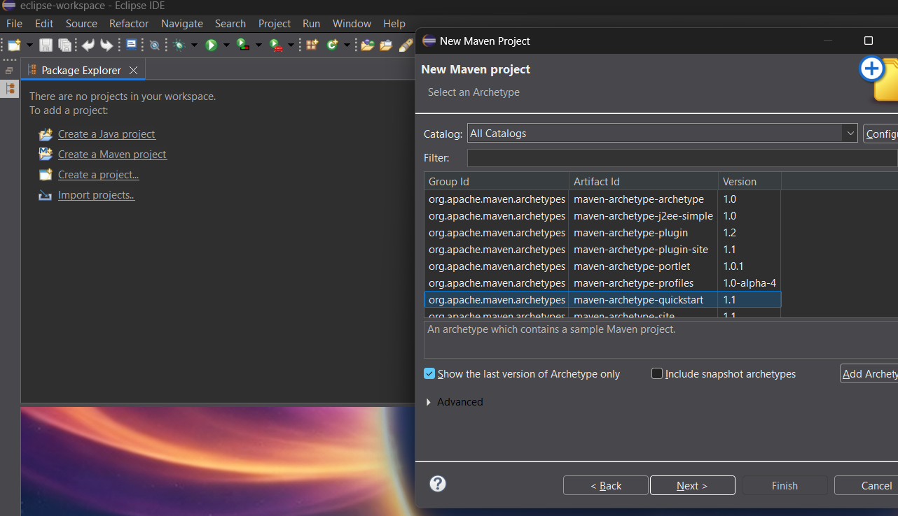

package com.cognizant.springlearn;

import java.text.SimpleDateFormat;
import java.util.Date;

import org.springframework.boot.SpringApplication;
import org.springframework.boot.autoconfigure.SpringBootApplication;
import org.springframework.context.ApplicationContext;
import org.springframework.context.support.ClassPathXmlApplicationContext;

@SpringBootApplication
public class SpringLearnApplication {

public static void main(String[] args) throws Exception {

SpringApplication.run(
SpringLearnApplication.class,
args
);

displayDate();
}

public static void displayDate() throws Exception {

ApplicationContext context =
new ClassPathXmlApplicationContext("date-format.xml");

SimpleDateFormat format =
context.getBean(
"dateFormat",
SimpleDateFormat.class
);

Date date =
format.parse("31/12/2018");

System.out.println(date);
}
}
sample output:
Mon Dec 31 00:00:00 IST 2018

Spring Core - Incorporate Logging



package com.cognizant.springlearn;

import java.text.SimpleDateFormat;
import java.util.Date;

import org.slf4j.Logger;
import org.slf4j.LoggerFactory;
import org.springframework.boot.SpringApplication;
import org.springframework.boot.autoconfigure.SpringBootApplication;
import org.springframework.context.ApplicationContext;
import org.springframework.context.support.ClassPathXmlApplicationContext;

@SpringBootApplication
public class SpringLearnApplication {

private static final Logger LOGGER =
LoggerFactory.getLogger(SpringLearnApplication.class);

public static void main(String[] args) throws Exception {

SpringApplication.run(
SpringLearnApplication.class,
args
);

displayDate();
}

public static void displayDate() throws Exception {

LOGGER.info("START");

ApplicationContext context =
new ClassPathXmlApplicationContext(
"date-format.xml"
);

SimpleDateFormat format =
context.getBean(
"dateFormat",
SimpleDateFormat.class
);

Date date =
format.parse("31/12/2018");

LOGGER.debug("Date : {}", date);

LOGGER.info("END");
}
}

Sample output:
INFO | START
DEBUG| Date : Mon Dec 31 00:00:00 IST 2018
INFO | END

Spring Core – Load Country from Spring Configuration XML

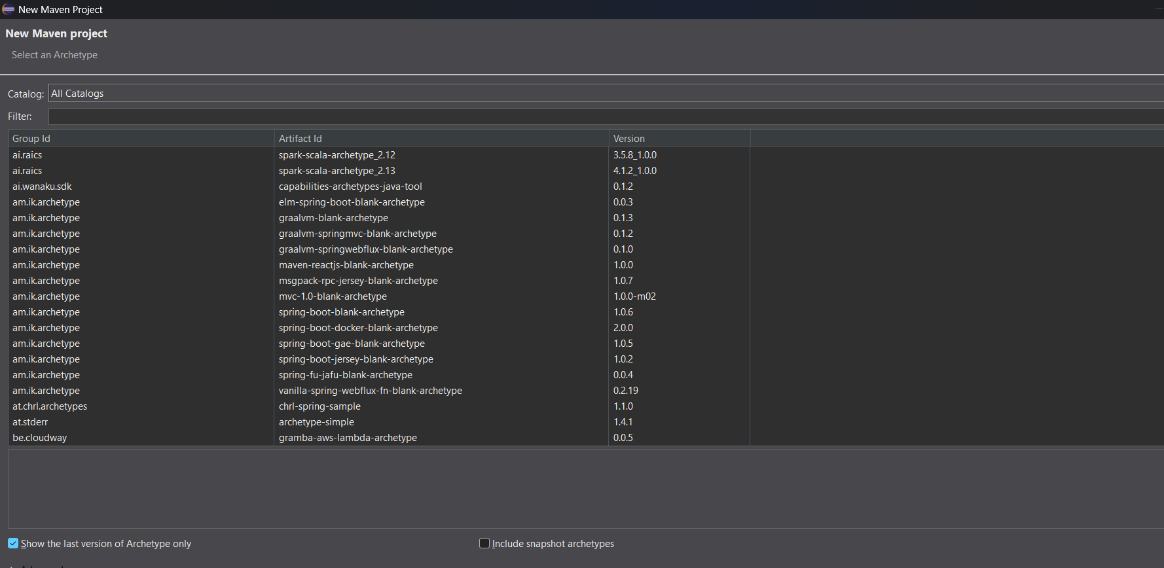

package com.cognizant.springlearn;

import org.slf4j.Logger;
import org.slf4j.LoggerFactory;

import org.springframework.boot.SpringApplication;
import org.springframework.boot.autoconfigure.SpringBootApplication;

import org.springframework.context.ApplicationContext;
import org.springframework.context.support.ClassPathXmlApplicationContext;

@SpringBootApplication
public class SpringLearnApplication {

private static final Logger LOGGER =
LoggerFactory.getLogger(
SpringLearnApplication.class
);

public static void main(String[] args) {

SpringApplication.run(
SpringLearnApplication.class,
args
);

displayCountry();
}

public static void displayCountry() {

LOGGER.info("START");

ApplicationContext context =
new ClassPathXmlApplicationContext(
"country.xml"
);

Country country =
context.getBean(
"country",
Country.class
);

LOGGER.debug(
"Country : {}",
country.toString()
);

LOGGER.info("END");
}
}

Output:
START
Inside Country Constructor.
Inside setCode()
Inside setName()
Country : Country [code=IN, name=India]
END

Spring Core – Demonstration of Singleton Scope and Prototype Scope
<bean id="country"
class="com.cognizant.springlearn.Country">

<property name="code" value="IN" />
<property name="name" value="India" />

</bean>

public static void displayCountry() {

LOGGER.info("START");

ApplicationContext context =
new ClassPathXmlApplicationContext("country.xml");

Country country =
context.getBean("country", Country.class);

Country anotherCountry =
context.getBean("country", Country.class);

LOGGER.debug("Country : {}", country);

LOGGER.debug("Another Country : {}", anotherCountry);

LOGGER.debug("Same Object : {}",
country == anotherCountry);

LOGGER.info("END");
}

Output:
START
Inside Country Constructor.
Inside setCode()
Inside setName()
Country : Country [code=IN, name=India]
Another Country : Country [code=IN, name=India]
Same Object : true
END

Spring Core – Load list of countries from Spring Configuration XML

package com.cognizant.springlearn;

import java.util.List;

import org.slf4j.Logger;
import org.slf4j.LoggerFactory;

import org.springframework.boot.SpringApplication;
import org.springframework.boot.autoconfigure.SpringBootApplication;

import org.springframework.context.ApplicationContext;
import org.springframework.context.support.ClassPathXmlApplicationContext;

@SpringBootApplication
public class SpringLearnApplication {

private static final Logger LOGGER =
LoggerFactory.getLogger(SpringLearnApplication.class);

public static void main(String[] args) {

SpringApplication.run(
SpringLearnApplication.class,
args
);

displayCountries();
}

@SuppressWarnings("unchecked")
public static void displayCountries() {

LOGGER.info("START");

ApplicationContext context =
new ClassPathXmlApplicationContext("country.xml");

List<Country> countries =
context.getBean(
"countryList",
List.class
);

LOGGER.debug("Countries : {}", countries);

LOGGER.info("END");
}
}

class Country {

private static final Logger LOGGER =
LoggerFactory.getLogger(Country.class);

private String code;
private String name;

public Country() {

LOGGER.debug("Inside Country Constructor.");
}

public String getCode() {

LOGGER.debug("Inside getCode()");

return code;
}

public void setCode(String code) {

LOGGER.debug("Inside setCode()");

this.code = code;
}

public String getName() {

LOGGER.debug("Inside getName()");

return name;
}

public void setName(String name) {

LOGGER.debug("Inside setName()");

this.name = name;
}

@Override
public String toString() {

return "Country [code=" + code
+ ", name=" + name + "]";
}
}

<?xml version="1.0" encoding="UTF-8"?>

<beans xmlns="http://www.springframework.org/schema/beans"
xmlns:xsi="http://www.w3.org/2001/XMLSchema-instance"
xsi:schemaLocation="http://www.springframework.org/schema/beans
https://www.springframework.org/schema/beans/spring-beans.xsd">

<bean id="in"
class="com.cognizant.springlearn.Country">

<property name="code" value="IN"/>
<property name="name" value="India"/>

</bean>

<bean id="us"
class="com.cognizant.springlearn.Country">

<property name="code" value="US"/>
<property name="name" value="United States"/>

</bean>

<bean id="de"
class="com.cognizant.springlearn.Country">

<property name="code" value="DE"/>
<property name="name" value="Germany"/>

</bean>

<bean id="jp"
class="com.cognizant.springlearn.Country">

<property name="code" value="JP"/>
<property name="name" value="Japan"/>

</bean>

<bean id="countryList"
class="java.util.ArrayList">

<constructor-arg>

<list>

<ref bean="in"/>
<ref bean="us"/>
<ref bean="de"/>
<ref bean="jp"/>

</list>

</constructor-arg>

</bean>

</beans>

Output:
START
Inside Country Constructor.
Inside setCode()
Inside setName()
Inside Country Constructor.
Inside setCode()
Inside setName()
Inside Country Constructor.
Inside setCode()
Inside setName()
Inside Country Constructor.
Inside setCode()
Inside setName()

Countries : [
Country [code=IN, name=India],
Country [code=US, name=United States],
Country [code=DE, name=Germany],
Country [code=JP, name=Japan]
]

END

